7th international conference
“Arctic Shelf Development: Step by Step”
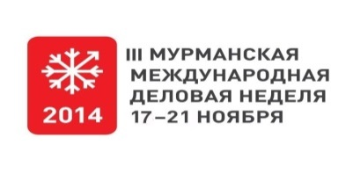
Organizer of the conference:  Association of suppliers for  oil and gas industry “Murmanshelf” |  | Co-organizer of the conference*:  Ministry of Economic Development of the Murmansk region  Committee for Development of Industry and Entrepreneurship of the Murmansk region |  |  | Supported by:  the Government of the Murmansk region
 |  | 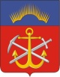
November 18, 2014
Location: Hotel “Arctic”/ Congress-hotel “Meridian” (under approval)
08:30 | Registration of the participants  Welcome coffee
09:15 – 09:30 | Official opening of the conference
09:30 – 10:45 | Plenary session 1  Cooperation between Russian and foreign companies in the development of offshore fields of the Norwegian, Barents, Pechora and Kara seas  Moderator: Grigory Stratiy, Vice Governor of Murmansk Region, Chairman of the Board of Association “Murmanshelf”  Key issues:  - Russian Arctic shelf: current condition, problems and prospects of oil and gas development  - Development of northern regions while prospecting continental shelf of Russian Arctic seas  - Usage of the nearest resources of Barents Sea for gasification of Murmansk
10:45 – 11:00 | Coffee break
11:00 – 12:30 | Plenary session 2  Arctic development: realization of projects, problems and possible variants to solve them, technological availability of industry  Moderator: Olga Buch, Director General of Association «Murmanshelf», PhD in Economics, professor  Key issues:  - Development of production base and coastal infrastructure  - Role of scientific and project organizations in creation of coastal infrastructure of developing objects on the Arctic shelf  - International cooperation of collaborating countries in the Arctic region
12:30 – 13:30 | Lunch for the participants of the conference
14:00 – 17:00 | B2B-meetings for the participants
17:30 | Reception for the participants of the conference
November 19, 2014
10:00 – 11:30 | Round table “International cooperation in OSR-operations in the Arctic region”  Moderators: Alexander Glazov, Director, “EcoService”  Olga Sarkova, Executive Director, “Industrial Safety Systems”  Key issues:  - Operators’ plans and needs in providing environmental safety of drilling operations in the Arctic region  - Planning of OSR-operations  - The Oil Spill Response Competence Center in the Arctic
11:30 – 12:00 | The Oil Spill Response Competence Center in the Arctic – presentation of the informational portal  Moderator: Olga Buch, Director General of Association «Murmanshelf»
12:00 – 12:15 | Coffee break
12:15 – 12:45 | Round table “Oil and gas industry: import substitution and localization”  Key issues:  - Localization and import substitution in Russian oil and gas industry  - Tendencies of development for Russian oilfield services companies  - The role of international cooperation in realization of such strategies
13:45 – 14:45 | Lunch for the participants of the conference

* Programme and themes of sessions may be changed
** According to a separate programme

